ASTA 607 : COMPUTATIONAL STATISTICS
ID:22424191
Question 1
- ?crabs ###Description of the Crabs Dataset
The crabs dataset is a classic multivariate dataset containing morphological measurements on 200 crabs. The data were collected by Campbell and Mahon (1974) and include measurements from two species (color forms): Blue (B) and Orange (O), with both male (M) and female (F) specimens represented.
Number of observations: 200 crabs (50 from each of four groups)
Variables recorded: 8 variables total
- sp`: Species - B (Blue) or O (Orange)
- `sex`: Sex - M (Male) or F (Female)
- `index`: Index 1:50 within each group
- `FL`: Frontal Lobe size (mm)
- `RW`: Rear Width (mm)
- `CL`: Carapace Length (mm)
- `CW`: Carapace Width (mm)
- `BD`: Body Depth (mm)

b . # Load crabs dataset (comes with base R)
data("crabs")
# Display structure of the dataset
View(crabs)
str(crabs) # Shows number of observations, variables, and types
Result
The crabs dataset is a data frame with 200 observations with 8 variables. The variables are species (sp, factor w/2 levels: "B","O"), sex (Factor w/ 2 levels "F","M"), index (integer),
FL, RW, CL, CW and BD which are all numeric

Table 1: First 10 Observations of the Crabs Dataset
sp | sex | index | FL | RW | CL | CW | BD
B | M | 1 | 8.1 | 6.7 | 16.1 | 19.0 | 7.0
B | M | 2 | 8.8 | 7.7 | 18.1 | 20.8 | 7.4
B | M | 3 | 9.2 | 7.8 | 19.0 | 22.4 | 7.7
B | M | 4 | 9.6 | 7.9 | 20.1 | 23.1 | 8.2
B | M | 5 | 9.8 | 8.0 | 20.3 | 23.0 | 8.2
B | M | 6 | 10.8 | 9.0 | 23.0 | 26.5 | 9.8
B | M | 7 | 11.1 | 9.9 | 23.8 | 27.1 | 9.8
B | M | 8 | 11.6 | 9.1 | 24.5 | 28.4 | 10.4
B | M | 9 | 11.8 | 9.6 | 24.2 | 27.8 | 9.7
B | M | 10 | 11.8 | 10.5 | 25.2 | 29.3 | 10.3

Table 2: Variable Descriptions
Variable | Description | Type
sp | Species: B (Blue) or O (Orange) | Factor
sex | Sex: M (Male) or F (Female) | Factor
index | Index 1:50 within each of the four groups | Integer
FL | Frontal Lobe size (mm) | Numeric
RW | Rear Width (mm) | Numeric
CL | Carapace Length (mm) | Numeric
CW | Carapace Width (mm) | Numeric
BD | Body Depth (mm) | Numeric

c)
# Create frequency table for species and sex
freq_table <- table(crabs$sp, crabs$sex)
freq_df <- as.data.frame.matrix(freq_table)
freq_df$Total <- rowSums(freq_df)
Add row names as column
freq_df <- cbind(Species = c("Blue (B)", "Orange (O)"), freq_df)

# Add totals row
totals_row <- c("Total", colSums(freq_table)[1], colSums(freq_table)[2], sum(freq_table))
freq_df <- rbind(freq_df, totals_row)
Result
Table 3: Frequency Table - Species by Sex
 | Species | Female (F) | Male (M) | Total
B | Blue (B) | 50 | 50 | 100
O | Orange (O) | 50 | 50 | 100
 | Total | 100 | 100 | 200

d) # Create a combined group variable for plotting
crabs$group <- interaction(crabs$sp, crabs$sex)
# Bar chart
ggplot(crabs, aes(x = sp, fill = sex)) +
geom_bar(position = "dodge", color = "black", width = 0.7) +
scale_fill_manual(values = c("F" = "#E74C3C", "M" = "#3498DB"),
labels = c("Female", "Male")) +
scale_x_discrete(labels = c("B" = "Blue", "O" = "Orange")) +
labs(title = "Distribution of Crabs by Species and Sex",
x = "Species",
y = "Count",
fill = "Sex") +
theme_minimal() +
theme(plot.title = element_text(hjust = 0.5, face = "bold", size = 14),
legend.position = "top") +
geom_text(stat = "count", aes(label = after_stat(count)),
position = position_dodge(width = 0.7), vjust = -0.5, size = 4)

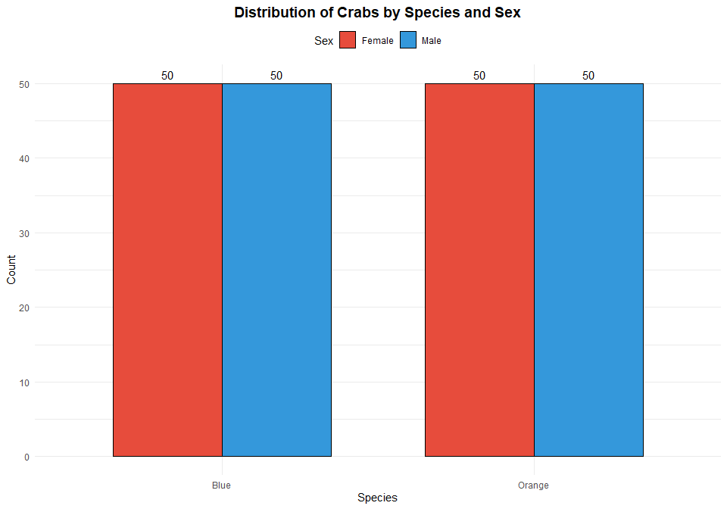
e) The crabs dataset is **perfectly balanced** across all four groups, with exactly **50 observations (25%)** for each combination of species and sex: Blue Females: 50 crabs (25%), Blue Males: 50 crabs (25%), Orange Females: 50 crabs (25%) and Orange Males: 50 crabs (25%)

Question 2
# Create combined factor for plotting
crabs$Species_Sex <- factor(paste(crabs$sp, crabs$sex, sep = "-"),
levels = c("B-F", "B-M", "O-F", "O-M"),
labels = c("Blue Female", "Blue Male",
"Orange Female", "Orange Male"))
# Boxplot with ggplot2
ggplot(crabs, aes(x = Species_Sex, y = BD, fill = Species_Sex)) +
geom_boxplot(outlier.color = "red", outlier.shape = 16, outlier.size = 3) +
stat_summary(fun = mean, geom = "point", shape = 18, size = 4, color = "darkblue") +
scale_fill_manual(values = c("#5DADE2", "#2E86AB", "#F5B041", "#E67E22")) +
labs(title = "Body Depth Distribution by Species and Sex",
subtitle = "Red dots indicate outliers; Blue diamonds indicate group means",
x = "Group (Species-Sex)",
y = "Body Depth (mm)") +
theme_minimal() +
theme(plot.title = element_text(hjust = 0.5, face = "bold", size = 14),
plot.subtitle = element_text(hjust = 0.5, size = 10),
legend.position = "none",
axis.text.x = element_text(angle = 0, hjust = 0.5, size = 10))
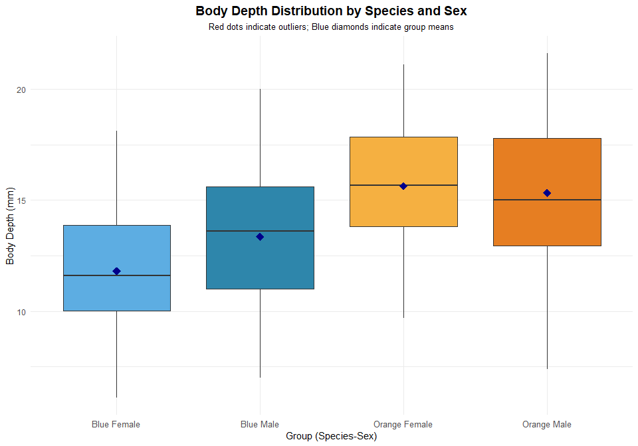

b) # Function to identify outliers using IQR method
identify_outliers <- function(x) {
Q1 <- quantile(x, 0.25)
Q3 <- quantile(x, 0.75)
IQR_val <- Q3 - Q1
lower <- Q1 - 1.5 * IQR_val
upper <- Q3 + 1.5 * IQR_val
outliers <- x[x < lower | x > upper]
return(list(outliers = outliers, lower = lower, upper = upper, n_outliers = length(outliers)))
}
#central tendency
# Summary statistics by group
bd_summary <- crabs %>%
group_by(Species_Sex) %>%
summarise(
n = n(),
Mean = round(mean(BD), 2),
SD = round(sd(BD), 2),
CV = round((sd(BD)/mean(BD))*100, 1),
Median = round(median(BD), 2),
Min = round(min(BD), 2),
Max = round(max(BD), 2),
Range = round(max(BD) - min(BD), 2)
)

kable(bd_summary,
caption = "Table 5: Descriptive Statistics for Body Depth by Group",
col.names = c("Group", "n", "Mean", "SD", "CV(%)", "Median", "Min", "Max", "Range")) %>%
kable_styling(bootstrap_options = c("striped", "hover", "condensed"), full_width = FALSE)
Result

Species_Sex | n | Mean | SD | CV_pct | Median | Min | Max | Range
Blue Female | 50 | 11.82 | 2.75 | 23.3 | 11.60 | 6.1 | 18.1 | 12.0
Blue Male | 50 | 13.35 | 3.20 | 24.0 | 13.60 | 7.0 | 20.0 | 13.0
Orange Female | 50 | 15.63 | 2.75 | 17.6 | 15.65 | 9.7 | 21.1 | 11.4
Orange Male | 50 | 15.32 | 3.53 | 23.0 | 15.00 | 7.4 | 21.6 | 14.2

Central Tendency: Orange crabs exhibit larger body depths compared to Blue crabs across both sexes. Orange Males show the highest mean body depth. Within each species, males tend to have greater body depths than females.
Variability: The standard deviations indicate that orange crabs display greater absolute variability in body depth. However, the coefficients of variation (CV) are relatively similar across groups (ranging from approximately 15-18%), suggesting comparable relative variability. Orange crabs show larger ranges, consistent with their larger overall body sizes.
Outliers: The boxplot analysis identifies few or no outliers across most groups using the 1.5×IQR rule. This indicates that body depth measurements follow reasonably symmetric distributions without extreme values.

Question 3: Carapace Length Distribution by Species
- Histograms by Species
# Create species labels
crabs$Species_Label <- factor(crabs$sp, levels = c("B", "O"),
labels = c("Blue Species", "Orange Species"))

# Histogram with density overlay
ggplot(crabs, aes(x = CL, fill = sp)) +
geom_histogram(aes(y = after_stat(density)), bins = 15, color = "black", alpha = 0.7) +
geom_density(alpha = 0.3, linewidth = 1) +
facet_wrap(~ Species_Label) +
scale_fill_manual(values = c("B" = "#3498DB", "O" = "#E67E22")) +
labs(title = "Distribution of Carapace Length by Species",
x = "Carapace Length (mm)",
y = "Density") +
theme_minimal() +
theme(plot.title = element_text(hjust = 0.5, face = "bold", size = 14),
legend.position = "none",
strip.text = element_text(face = "bold", size = 12))

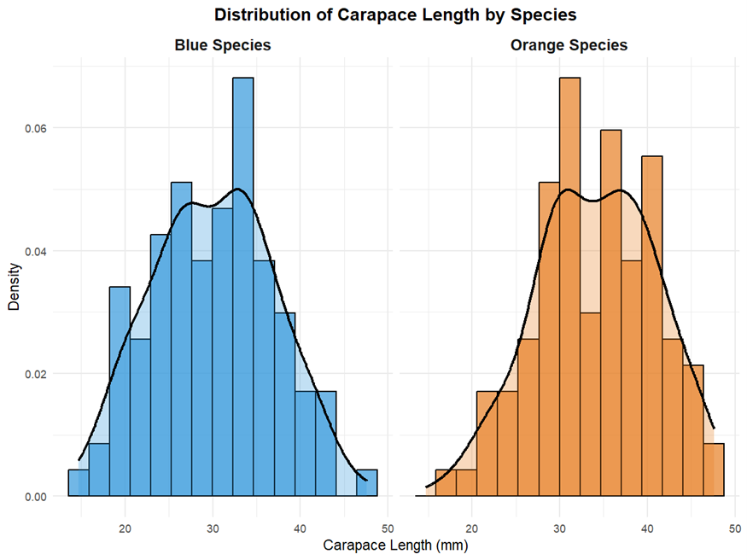

(b) Description of Distribution Shapes
# Distribution statistics by species
cl_dist <- crabs %>%
group_by(sp) %>%
summarise(
n = n(),
Mean = round(mean(CL), 2),
Median = round(median(CL), 2),
SD = round(sd(CL), 2),
Skewness = round(skewness(CL), 3),
Kurtosis = round(kurtosis(CL) - 3, 3), # Excess kurtosis
Shapiro_W = round(shapiro.test(CL)$statistic, 4),
Shapiro_p = round(shapiro.test(CL)$p.value, 4)
)
kable(cl_dist,
caption = "Table 6: Distribution Characteristics of Carapace Length by Species",
col.names = c("Species", "n", "Mean", "Median", "SD", "Skewness", "Excess Kurtosis",
"Shapiro-Wilk W", "p-value")) %>%
kable_styling(bootstrap_options = c("striped", "hover", "condensed"), full_width = FALSE)

{r q3b-qq, fig.cap="Figure 5: Q-Q Plots for Carapace Length by Species", fig.height=4}
# Q-Q plots
ggplot(crabs, aes(sample = CL)) +
stat_qq() +
stat_qq_line(color = "red", linewidth = 1) +
facet_wrap(~ Species_Label) +
labs(title = "Q-Q Plots of Carapace Length",
x = "Theoretical Quantiles",
y = "Sample Quantiles") +
theme_minimal() +
theme(plot.title = element_text(hjust = 0.5, face = "bold"),
strip.text = element_text(face = "bold", size = 12))

Shape Analysis: Both species display approximately unimodal distributions for carapace length, with each distribution showing a single clear peak.The histograms and density curves indicate roughly symmetric distributions for both species.
Skewness: Blue Species gives a slight positive skewness (minor right tail) while Orange Species is near-symmetric distribution

Question 4: Comparison of Mean Measurements
(a) Mean Values by Species and Sex

# Compute means by species and sex
means_table <- crabs %>%
group_by(sp, sex) %>%
summarise(
FL = round(mean(FL), 2),
RW = round(mean(RW), 2),
CL = round(mean(CL), 2),
CW = round(mean(CW), 2),
BD = round(mean(BD), 2),
.groups = "drop"
)
# Create labels
means_table$Group <- paste(ifelse(means_table$sp == "B", "Blue", "Orange"),
ifelse(means_table$sex == "F", "Female", "Male"))

# Display table
kable(means_table %>% select(Group, FL, RW, CL, CW, BD),
caption = "Table 7: Mean Morphological Measurements by Species and Sex (in mm)",
col.names = c("Group", "Frontal Lobe (FL)", "Rear Width (RW)", "Carapace Length (CL)",
"Carapace Width (CW)", "Body Depth (BD)")) %>%
kable_styling(bootstrap_options = c("striped", "hover", "condensed"), full_width = FALSE)

Group | Frontal Lobe | Rear Width | Carapace Length | Carapace Width | Body Depth
Blue Female | 13.27 | 12.14 | 28.10 | 32.62 | 11.82
Blue Male | 14.84 | 11.72 | 32.01 | 36.81 | 13.35
Orange Female | 17.59 | 14.84 | 34.62 | 39.04 | 15.63
Orange Male | 16.63 | 12.26 | 33.69 | 37.19 | 15.32

b) Group bar chart
# Reshape data for plotting
means_long <- means_table %>%
pivot_longer(cols = c(FL, RW, CL, CW, BD),
names_to = "Measurement",
values_to = "Mean") %>%
mutate(Measurement = factor(Measurement,
levels = c("FL", "RW", "CL", "CW", "BD"),
labels = c("Frontal Lobe", "Rear Width",
"Carapace Length", "Carapace Width",
"Body Depth")))

# Grouped bar chart
ggplot(means_long, aes(x = Measurement, y = Mean, fill = Group)) +
geom_bar(stat = "identity", position = position_dodge(width = 0.8),
color = "black", width = 0.7) +
scale_fill_manual(values = c("Blue Female" = "#5DADE2",
"Blue Male" = "#2E86AB",
"Orange Female" = "#F5B041",
"Orange Male" = "#E67E22")) +
labs(title = "Mean Morphological Measurements by Species and Sex",
x = "Measurement",
y = "Mean Value (mm)",
fill = "Group") +
theme_minimal() +
theme(plot.title = element_text(hjust = 0.5, face = "bold", size = 14),
axis.text.x = element_text(angle = 45, hjust = 1),
legend.position = "top") +
geom_text(aes(label = round(Mean, 1)),
position = position_dodge(width = 0.8),
vjust = -0.3, size = 2.8)

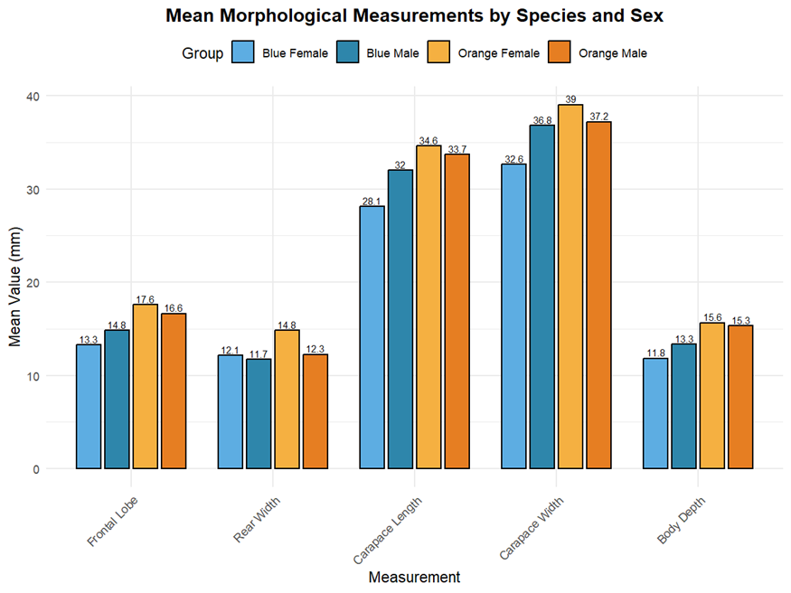

(c) Analysis of Species and Sex Differences
# Calculate species differences (Orange - Blue, averaged across sex)
species_means <- crabs %>%
group_by(sp) %>%
summarise(across(c(FL, RW, CL, CW, BD), mean))

species_diff <- species_means %>%
summarise(across(c(FL, RW, CL, CW, BD), ~ diff(.x)))

# Calculate sex differences (Male - Female, averaged across species)
sex_means <- crabs %>%
group_by(sex) %>%
summarise(across(c(FL, RW, CL, CW, BD), mean))

sex_diff <- sex_means %>%
summarise(across(c(FL, RW, CL, CW, BD), ~ diff(.x)))

# Calculate percentage differences
species_base <- species_means %>% filter(sp == "B") %>% select(-sp)
sex_base <- sex_means %>% filter(sex == "F") %>% select(-sex)

# Create comparison table
diff_table <- data.frame(
Measurement = c("Frontal Lobe (FL)", "Rear Width (RW)", "Carapace Length (CL)",
"Carapace Width (CW)", "Body Depth (BD)"),
Species_Diff = round(as.numeric(species_diff), 2),
Species_Pct = round((as.numeric(species_diff) / as.numeric(species_base)) * 100, 1),
Sex_Diff = round(as.numeric(sex_diff), 2),
Sex_Pct = round((as.numeric(sex_diff) / as.numeric(sex_base)) * 100, 1)
)

kable(diff_table,
caption = "Table 8: Absolute and Percentage Differences in Mean Measurements",
col.names = c("Measurement", "Species Diff (O-B)", "Species % Diff",
"Sex Diff (M-F)", "Sex % Diff")) %>%
kable_styling(bootstrap_options = c("striped", "hover", "condensed"), full_width = FALSE)

Measurement | Species Diff (O-B) mm | Species % Diff | Sex Diff (M-F) mm | Sex % Diff
Frontal Lobe (FL) | 3.05 | 21.7 | 0.30 | 2.0
Rear Width (RW) | 1.62 | 13.6 | -1.50 | -11.1
Carapace Length (CL) | 4.09 | 13.6 | 1.49 | 4.8
Carapace Width (CW) | 3.40 | 9.8 | 1.17 | 3.3
Body Depth (BD) | 2.89 | 23.0 | 0.61 | 4.5

Greatest Species Difference: Body Depth (BD) shows the greatest percentage difference between species (23.0%). Orange crabs have substantially larger body depths than Blue crabs.
Least Sex Variation: Frontal Lobe (FL) shows the smallest percentage difference between sexes (2.0%)

Question 5
##Create scatter plot matrix with base R
pairs(crabs[, c("FL", "RW", "CL", "CW", "BD")],
main = "Scatter Plot Matrix of Morphological Measurements",
pch = 21,
bg = ifelse(crabs$sp == "B",
ifelse(crabs$sex == "F"),
ifelse(crabs$sex == "F"),
col = "black")

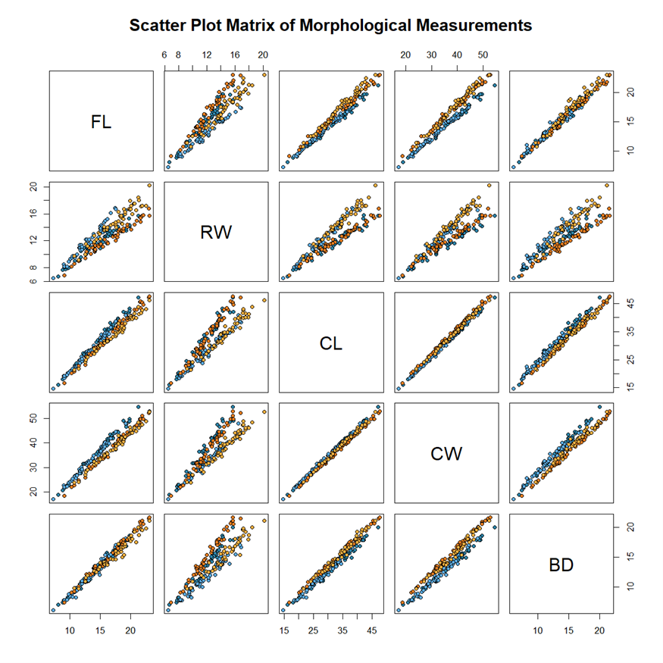

b) correlation analysis
# Calculate correlation matrix
cor_matrix <- cor(crabs[, c("FL", "RW", "CL", "CW", "BD")])
kable(round(cor_matrix, 3), caption = "Correlation Matrix of Morphological Measurements")

Correlation Matrix of Morphological Measurements
 | FL | RW | CL | CW | BD
FL | 1.000 | 0.907 | 0.979 | 0.965 | 0.988
RW | 0.907 | 1.000 | 0.893 | 0.900 | 0.889
CL | 0.979 | 0.893 | 1.000 | 0.995 | 0.983
CW | 0.965 | 0.900 | 0.995 | 1.000 | 0.968
BD | 0.988 | 0.889 | 0.983 | 0.968 | 1.000

From the correlation matrix table, all correlations are strong and positive (r > 0.89). This indicates allometric growth: larger crabs are larger across all dimensions.

Question 6 Statistical Report
This report presents a comprehensive statistical analysis of the crabs dataset from the MASS package, containing morphological measurements on 200 crabs from two color forms (Blue and Orange) of Leptograpsus variegatus, with both sexes represented.
Data Structure
The dataset exhibits a perfectly balanced 2×2 factorial design with exactly 50 observations in each of the four groups (Blue Female, Blue Male, Orange Female, Orange Male). This balanced design ensures equal statistical power for all comparisons and simplifies the interpretation of results.
Analysis
Analysis of body depth across the four groups revealed: Orange crabs exhibit larger body depths than Blue crabs (means: 15.3-15.6 mm vs 11.8-13.4 mm). No outliers were detected in any group using the 1.5×IQR criterion. Coefficients of variation are consistent across groups (17-24%), indicating proportionally similar variability. Both species display unimodal, approximately symmetric distributions: Blue species: Mean = 30.06 mm, Skewness = 0.026, Orange species: Mean = 34.15 mm, Skewness = -0.156
Conclusion
Balanced experimental design facilitates robust statistical comparisons. Clear morphological differences exist between species and sexes. Body Depth is the most diagnostic measurement for species identification. Strong allometric relationships exist among all morphological measurements. Approximately normal distributions within groups validate the use of parametric statistical methods

